OLCAA
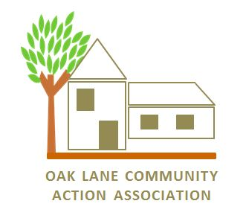
Oak Lane Community Action Association
P.O. Box 2926 Philadelphia, PA 19141 215 224-2777
olcaa.eol@gmail.com www.olcaa.org

Greetings Perspective Corporate Sponsor,

Thank you for your kind consideration to become a community partner. On Saturday September 22nd, 2018 the Oak Lane Community Action Association (OLCAA) will hosts its 46th “Oak Lane Day” fund-raising event. We are a community in upwards of 1800 households.
This annual event is hosted by OLCAA designed to help raise the necessary financial support that allows the organization to continue its service to the Philadelphia neighborhood of East Oak Lane and its adjacent communities.
As the ‘anchor’ neighborhood situated at the very top of Broad Street in the Upper North of Philadelphia, Oak Lane is a thriving cultural and economically diverse community that supports and benefits from the various committees provided by OLCAA, such as Housing & Zoning, Crime & Safety, Beautification and Development...just to name a few. OLCAA hosts various symposiums throughout the year that mainly focus on important Quality of Life issues that the residents greatly appreciate and look forward to.
OLCAA, since its founding in 1970, is recognized by city and state government officials as a powerful community voice for more than 40+ years of its existence. However; for OLCAA to continue to develop and implement new strategies that will help us keep up with the ever-growing needs of our community, we host our popular “Oak Lane Day” fund-raiser.
This year we challenge ourselves to fill 100 backpacks for Elwood school, distribute care packages for 50 home bound seniors. Here are some of the attractions that will be featured at the festival, a mini Health Pavilion, Kids Zone, Music, Informational and Local Retail Vendors.

The following is information of our non-profit status:
“Oak Lane Community Action Association is tax exempt and is classified as a 501 (c)(3) under the Internal Revenue Code. We are also classified as a public charity under section 509(c)(2). Under section 170 of the Code we are qualified to receive tax deductible bequests, devises, transfers, or gifts under section 2055, 2106 or 2522 of the Internal Revenue Code. Our Federal Identification Number is: 23-2096789.”

Thank you in advance for your support. If you have any questions, do not hesitate to call at MS Ferebee 267 237 5350 or leave a message on our OLCAA Hotline at 215.224.2777. You can email us at olcaa.eol@gmail.com. Visit our website www.olcaa.org

Gratefully Yours,

Sharon Wilson Andrea Mayo Smiley Ferebee Eric Brice OLCAA President OLCAA Vice Mayo Oak Lane Day Chairperson Oak Lane Day Co Chair

